Enumerate() in Python with EXAMPLES

Sometimes you want to reference your items in the list or other data structure for later use. Python makes it easier by providing an enumerate function.

Let's take a look at the parameter of enumerate.

enumerate(iterable, startIndex)

* **Iterable**: list or other iterable.
* **StartIndex**: It is the starting number. StartIndex is optional.

Let’s take a look at the code.

|  |
| --- |
| name = ['Alex', 'Bob' ,'Celvin', 'Dexter'] e_name = enumerate(name) print(e_name) |

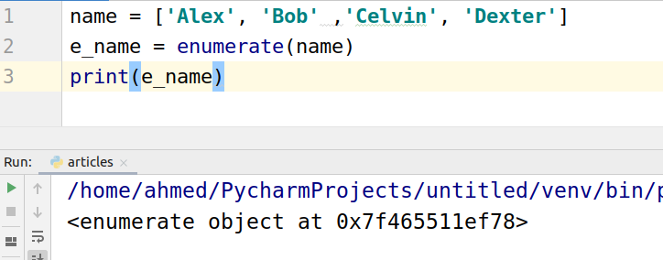

The enumerate function returns an enumerate object that we need to iterate to get the output values. Let us iterate through the list.

|  |
| --- |
| name = ['Alex', 'Bob' ,'Celvin', 'Dexter'] e_name = enumerate(name) for i in e_name:  print(i) |

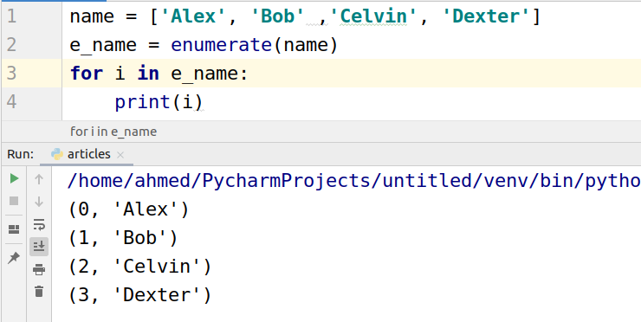

Now let’s start counting from 5 now.

|  |
| --- |
| name = ['Alex', 'Bob' ,'Celvin', 'Dexter'] e_name = enumerate(name,5) for i in e_name:  print(i) |

The following is the output

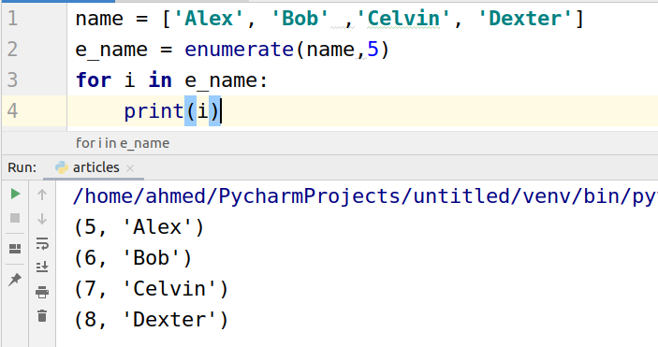

## Enumerating a Tuple

The enumerate on tuple works the same as on lists.

|  |
| --- |
| name = ('Alex', 'Bob' ,'Celvin', 'Dexter') e_name = enumerate(name) for i in e_name:  print(i) |

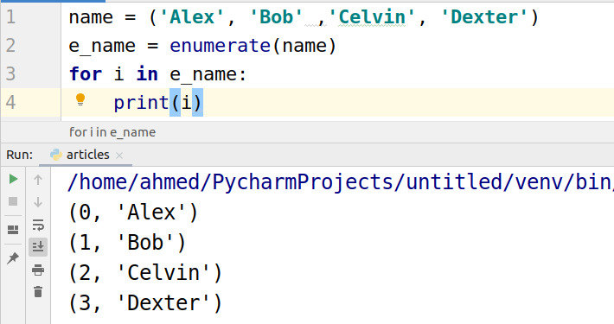

## Enumerating a String

Let’s take a look at the code to enumerate string.

|  |
| --- |
| name = ('Hello') e_name = enumerate(name) for i in e_name:  print(i) |

